PRACTICE 4

Determine the validity of the following three statements. Circle either True or False.

1. Group functions work across many rows to produce one result per group.  
 True/False

🡪 True

2. Group functions include nulls in calculations.  
 True/False

-🡪 False

3. The WHERE clause restricts rows prior to inclusion in a group calculation.  
 True/False

The HR department needs the following reports:

4. Find the highest, lowest, sum, and average salary of all employees. Label the columns  
 Maximum, Minimum, Sum, and Average, respectively.



-🡪 **select max(salary) as max,min(salary) as min,sum(salary) as sum,avg(salary) as avg**

**from employees;**

1. **Modify the query in lab_04 to display the minimum, maximum, sum, and average salary for each job type.**

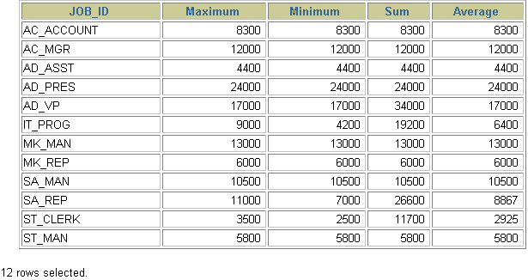

-🡪 **select max(salary) as max,min(salary) as min,sum(salary) as sum,avg(salary) as avg**

**from employees**

**group by job_id;**

1. Write a query to display the number of people with the same job.

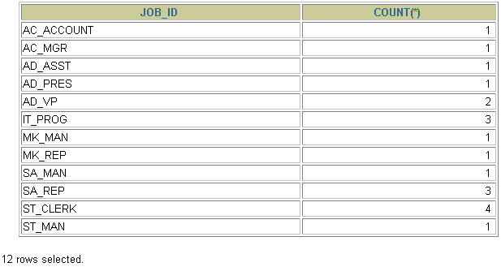

**--🡪 select max(salary) as max, min(salary) as min, sum(salary) as sum, avg(salary) as avg**

**from employees**

**group by job_id;**

7. Determine the number of managers without listing them. Label the column Number of Managers.



--🡪 **select count(distinct manager_id) as "Number of managers"**

**from employees;**

**8.Find the difference between the highest and lowest salaries. Label the column DIFFERENCE.**



-🡪 **select max(salary) - min(salary) as difference**

**from employees;**